ASSIGNMENT NO. 9
Data Retrieval, Functions, and Joins in MySQL

Objective: To combine results from multiple SELECT queries using UNION, UNION ALL, INTERSECT, and EXCEPT, and apply filtering and analytical queries.

Q1) Create CollegeDB with OnlineEnrollment and OfflineEnrollment and insert at least 6 records into each.
Column Name | Data Type | Constraint
StudentID | INT | PRIMARY KEY
StudentName | VARCHAR(50) | NOT NULL
Course | VARCHAR(30)
City | VARCHAR(30)
Marks | INT

CREATE DATABASE CollegeDB;
USE CollegeDB;

CREATE TABLE OnlineEnrollment ( StudentID INT PRIMARY KEY, StudentName VARCHAR(50) NOT NULL, Course VARCHAR(30),
City VARCHAR(30),
Marks INT
);

CREATE TABLE OfflineEnrollment ( StudentID INT PRIMARY KEY, StudentName VARCHAR(50) NOT NULL, Course VARCHAR(30),
City VARCHAR(30),
Marks INT
);

INSERT INTO OnlineEnrollment VALUES
(1, 'Rahul Sharma', 'BSc IT', 'Mumbai', 78),
(2, 'Priya Patil', 'BCA', 'Pune', 85),
(3, 'Aman Verma', 'BSc CS', 'Nashik', 67),
(4, 'Sneha Joshi', 'BSc IT', 'Mumbai', 91),
(5, 'Karan Mehta', 'BCA', 'Thane', 74),
(6, 'Neha Shah', 'BSc IT', 'Pune', 88);

INSERT INTO OfflineEnrollment VALUES
(4, 'Sneha Joshi', 'BSc IT', 'Mumbai', 91),
(5, 'Karan Mehta', 'BCA', 'Thane', 74),
(7, 'Rohan Desai', 'BSc CS', 'Mumbai', 69),
(8, 'Meera Kulkarni', 'BCA', 'Nashik', 82),
(9, 'Arjun Nair', 'BSc IT', 'Thane', 59),
(10, 'Divya More', 'BCA', 'Mumbai', 93);

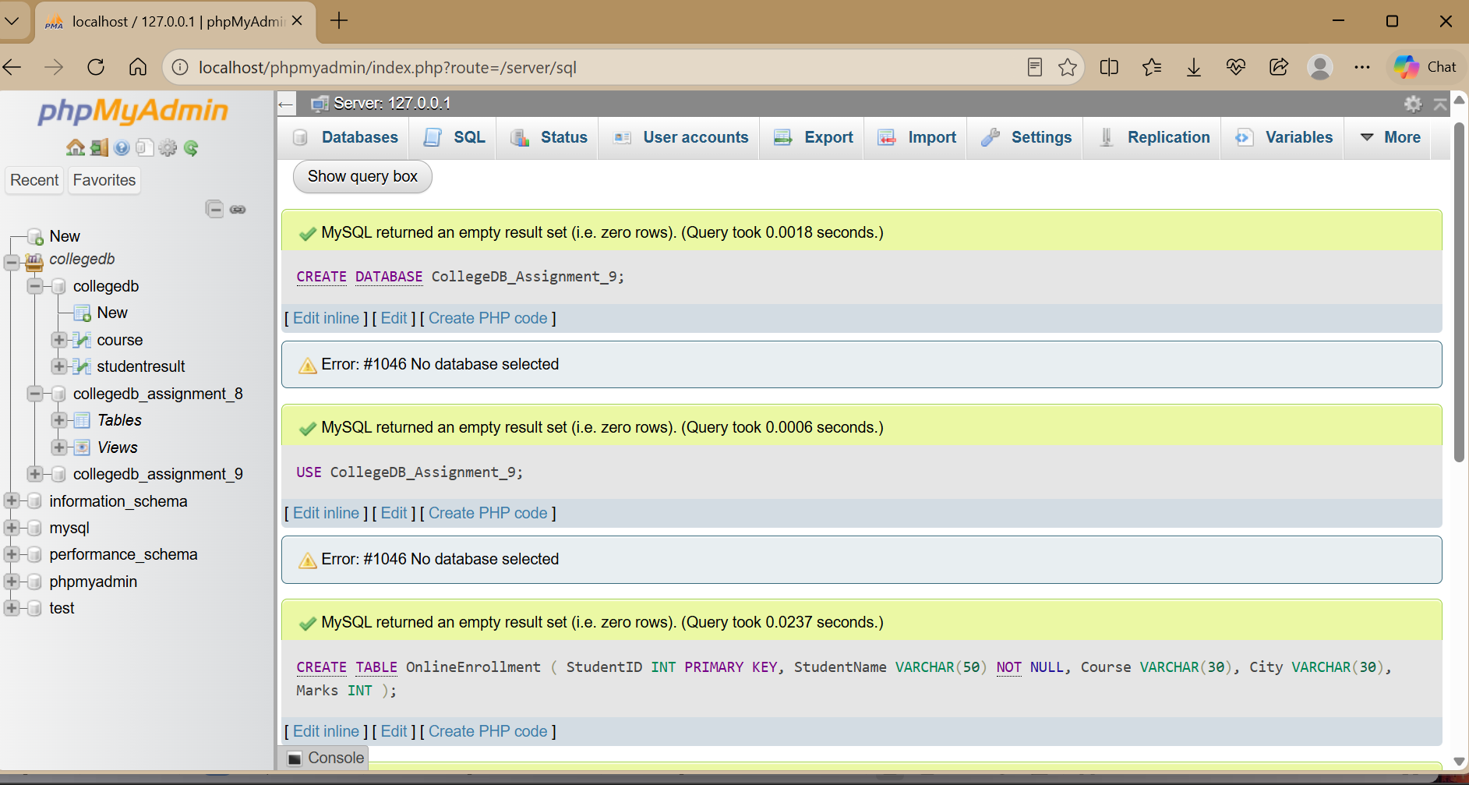

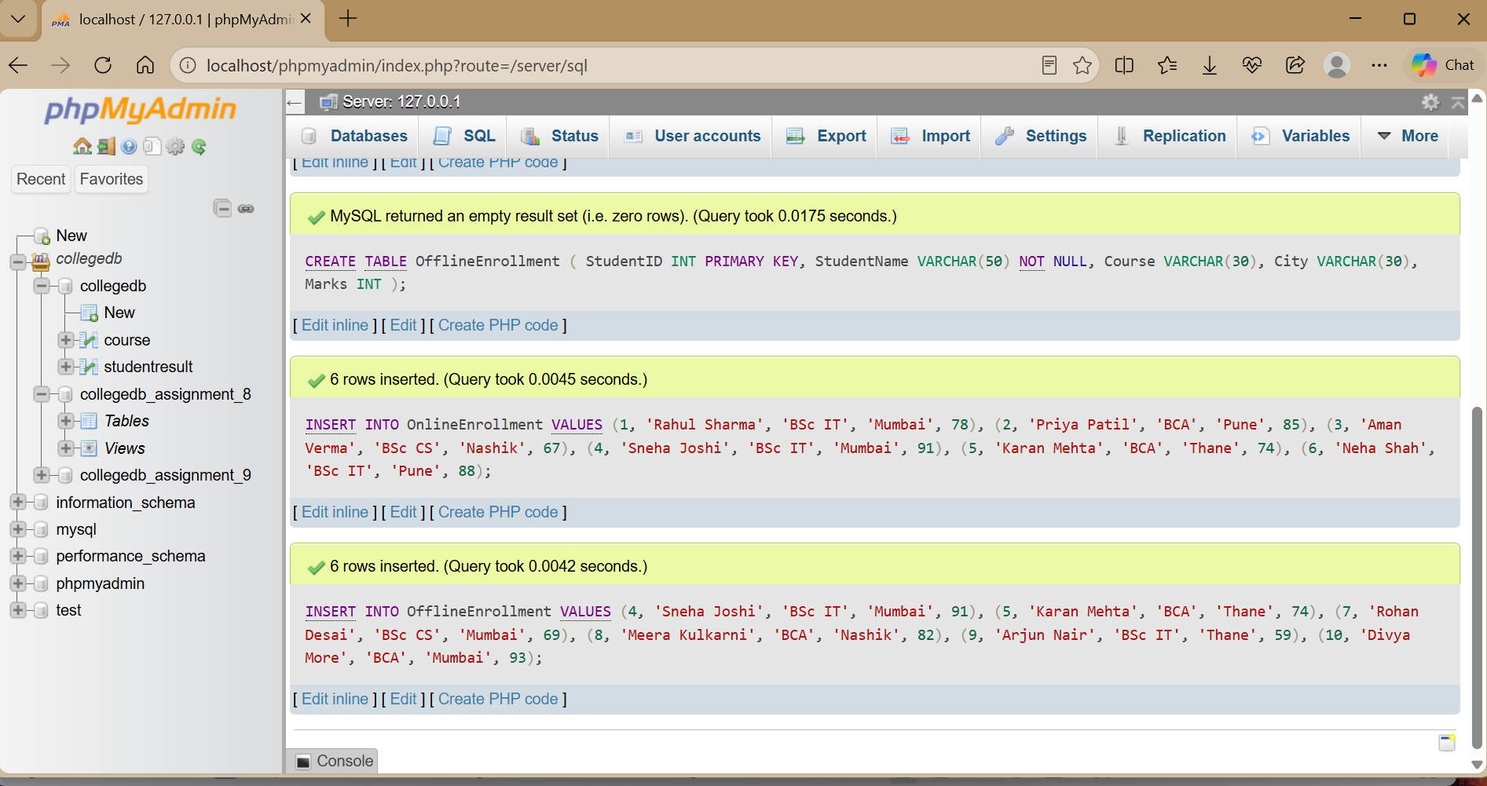

Q2) Use UNION to display all unique students from both tables.

SELECT StudentID, StudentName, Course, City, Marks FROM OnlineEnrollment
UNION

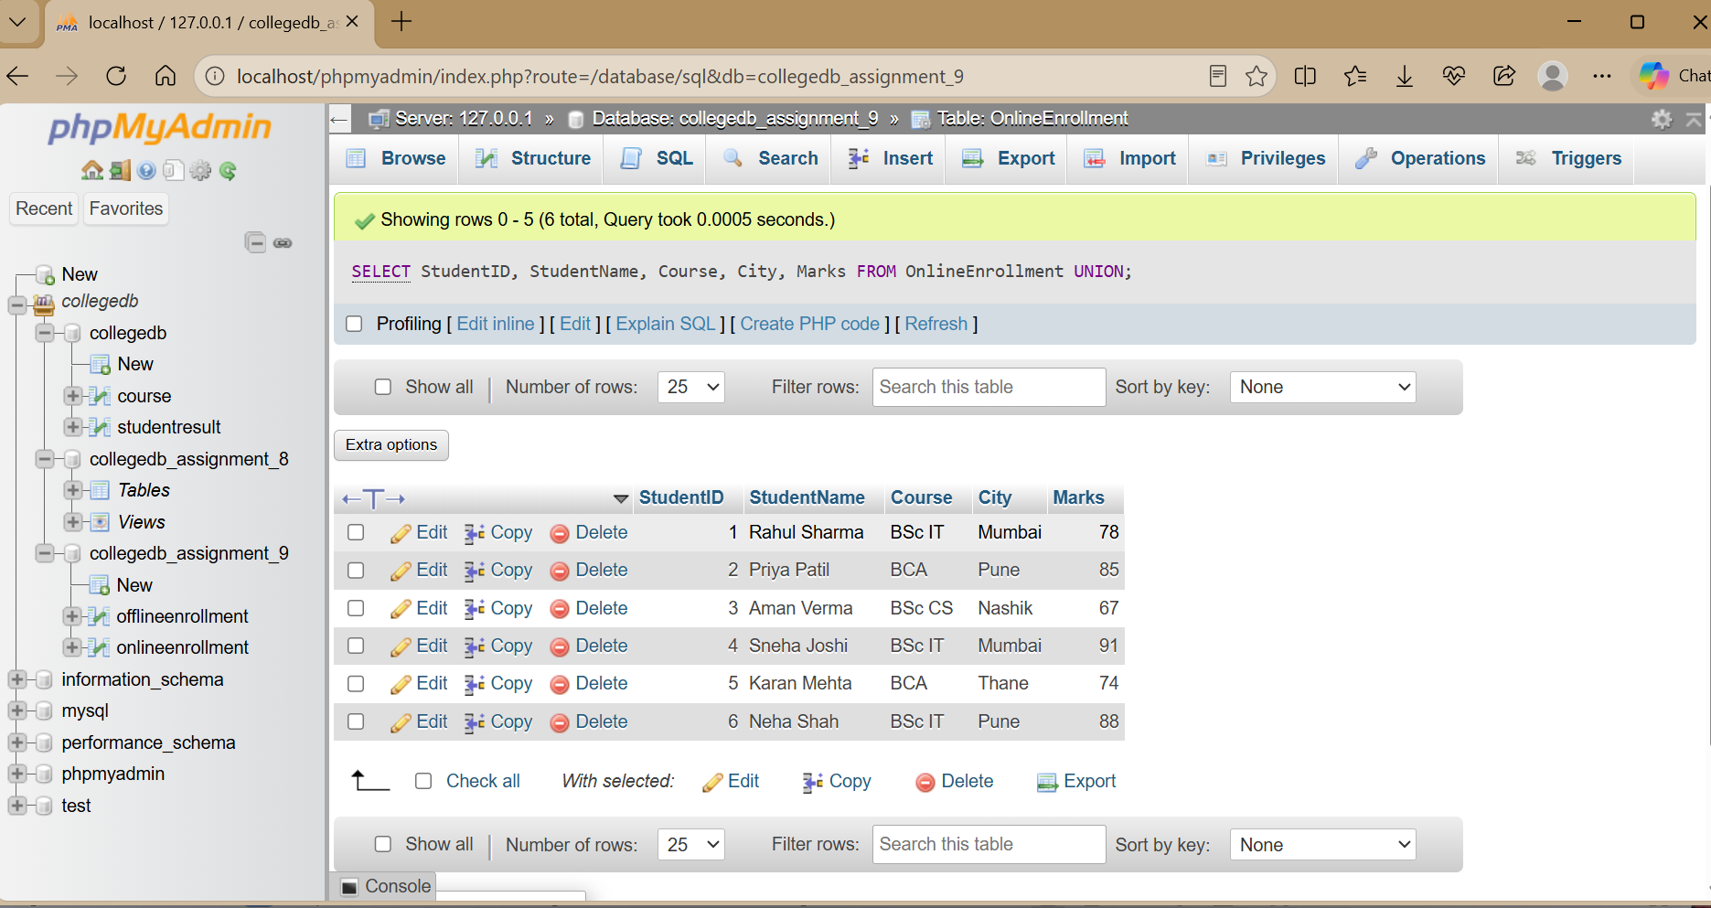

SELECT StudentID, StudentName, Course, City, Marks FROM OfflineEnrollment;

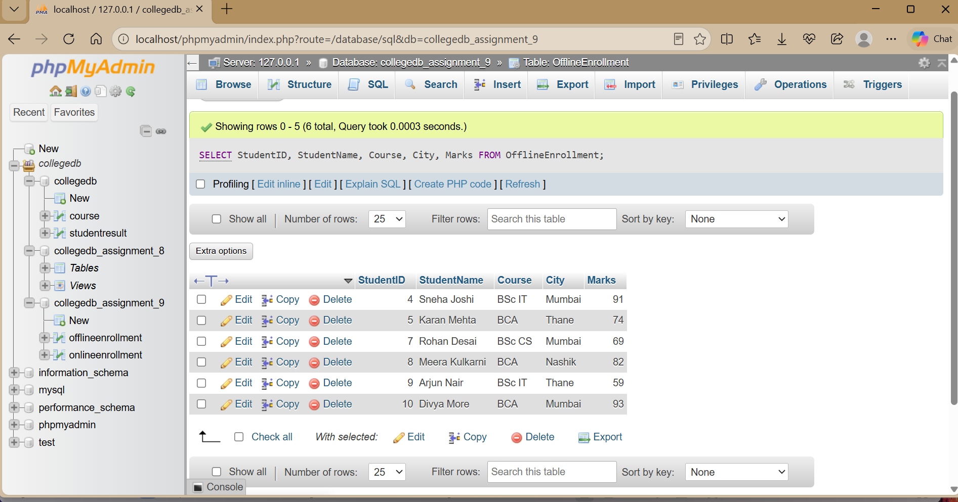

UNION combines the two result sets and removes duplicate rows.

Q3) Use UNION ALL and explain the difference between UNION and UNION ALL.

ELECT StudentID, StudentName, Course FROM OnlineEnrollment
UNION ALL
SELECT StudentID, StudentName, Course FROM OfflineEnrollment;

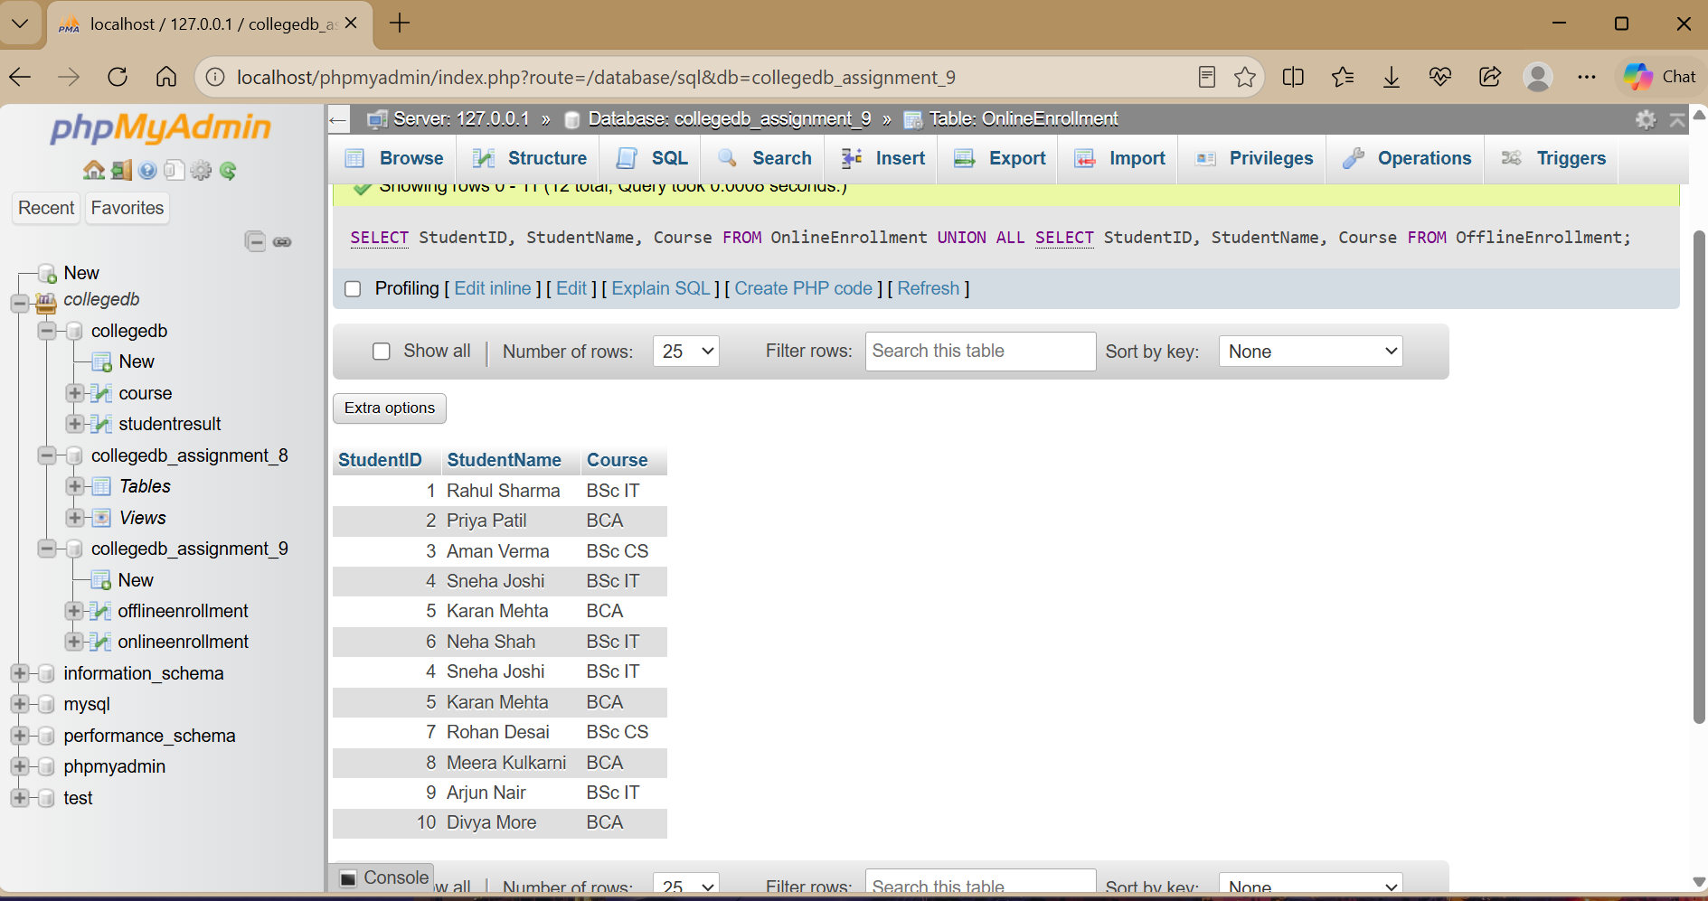

Difference: UNION removes duplicate rows, while UNION ALL keeps duplicate rows.

Q4) Use INTERSECT to display students present in both tables.

SELECT StudentID, StudentName, Course, City, Marks FROM OnlineEnrollment
INTERSECT
SELECT StudentID, StudentName, Course, City, Marks FROM OfflineEnrollment;

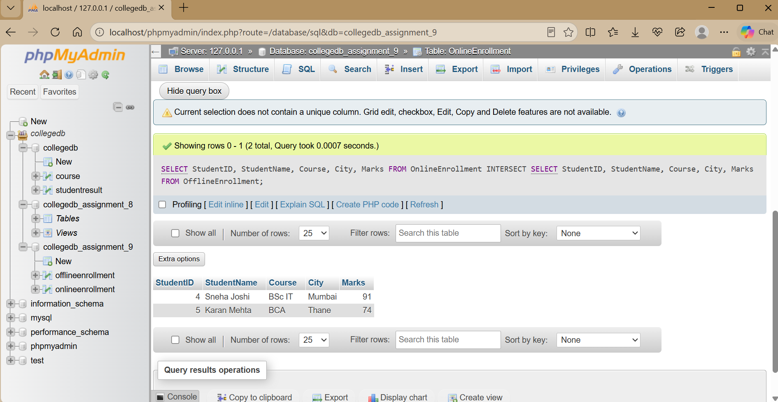

The result contains the records common to both enrollment sources.

Q5) Use EXCEPT to display students present only in OnlineEnrollment.

SELECT StudentID, StudentName, Course, City, Marks FROM OnlineEnrollment
EXCEPT
SELECT StudentID, StudentName, Course, City, Marks FROM OfflineEnrollment;

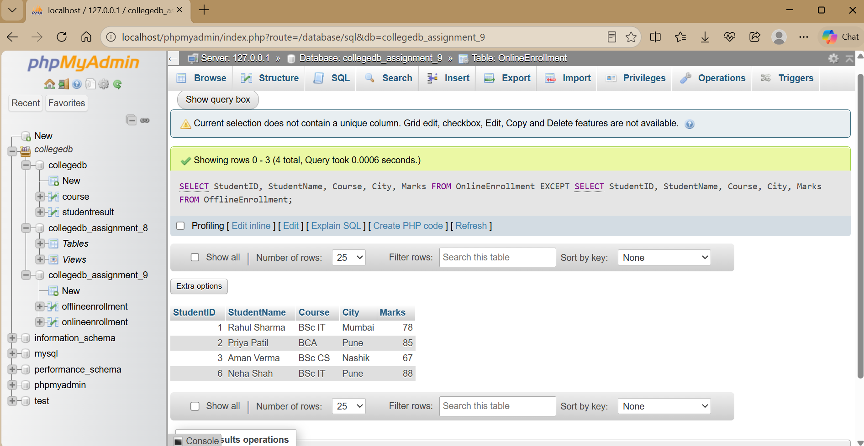

The result contains rows returned by the first query that are not returned by the second query.

Q6) Display high-scoring students from both tables.

SELECT StudentID, StudentName, Course, Marks FROM OnlineEnrollment
WHERE Marks >= 85 UNION
SELECT StudentID, StudentName, Course, Marks FROM OfflineEnrollment
WHERE Marks >= 85 ORDER BY Marks DESC;

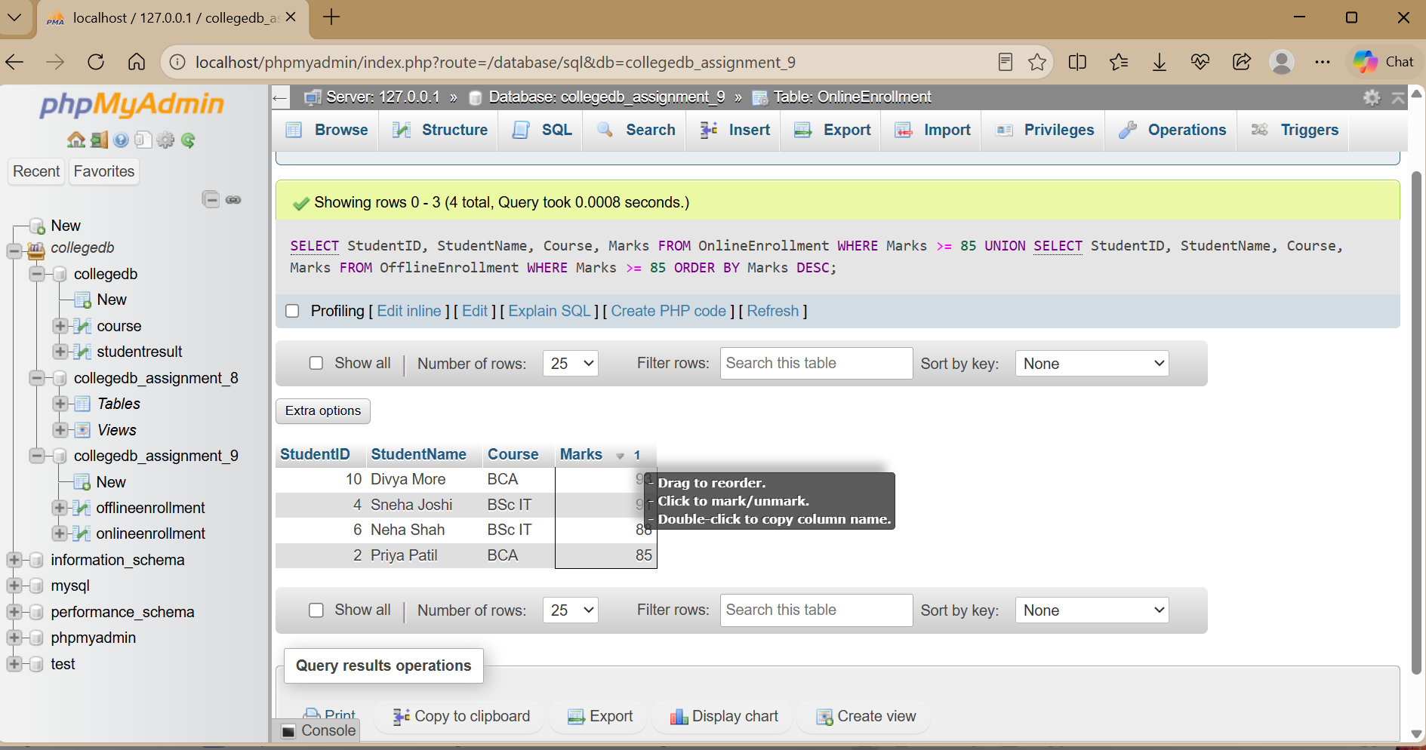

The WHERE condition filters high-scoring students before the UNION combines the results. ORDER BY sorts the final result.

THANK YOU

